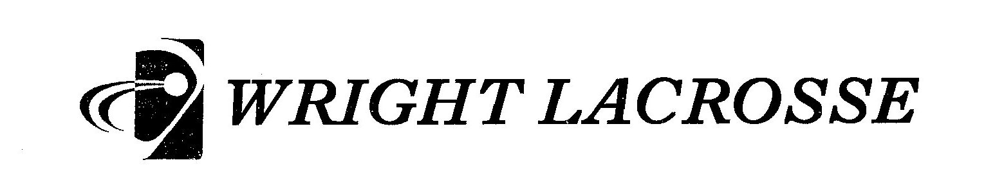

‘18
P

Equipment and Apparel Order

It is our desire for members of the program to have apparel and equipment that helps them train and compete to the best of their ability, and at the same time represents the team and the school well. It is also our desire that members of the team appear “uniform” when they are involved in team activities. We want to bring the same sense of unity, purpose and focus that we would have for games, to everything we do as a team.
All uniforms - game jerseys and game shorts, will be provided to players, on a loan basis. Uniforms will be issued to players, and collected from them when the season ends, or when their tenure with team comes to an end. No one has to purchase any part of the game uniform.
We ask that all players purchase a Spirit Pack. This contains 2 grey team-wear t-shirts in the 2018 design, Carolina Blue 2018 Practice shorts, and a reversible 2018 Practice Pinnie. Players are asked to wear Carolina blue shorts and the reversible jersey to all practices, and the grey shirts are required to be worn under game jerseys. We also offer Under Armour t-shirts in the same design as the grey t-shirts if players want to buy those to wear under their game jerseys.
For cold weather, players will need to have plain grey sweat pants and a plain grey hoodie – if not the team ones, then just plain grey
Attached is an order form for equipment and apparel. In order to have these items so that players can have them for training, and in some cases, for the start of the season, we need to get these orders placed soon. All orders are due by Monday December 11th. It is appreciated if you can include payment when placing your order, however, if need be, you can wait to pay until the orders are delivered. Checks can be made out to C. Milton Wright High School.
I will have sample sizes in my room starting on Monday November 27th. Please order sizes accordingly, and know that we cannot be responsible for incorrect sizing.
We may place another order for some these a few weeks before the season, but we will not have this order filled for the start of the season.

**In addition, if you purchase items, they are yours, regardless of what transpires for your son between now and the season – he decides not to play, becomes academically ineligible, etc. We will not buy back and apparel or equipment, or refund any money. The only exception to this would be if your son it cut from the team during tryouts – in this case, we will buy back from you the Spirit Pack.**

‘18
P

Player’s Name___________________________________

Qty
 | SPIRIT PACK
 | Practice Shorts  ($27) | S M L XL 2XL
 | T-Shirts  (2 x $10) | S M L XL 2XL
Practice Jersey
($25)
 |  |  | $72
 | UA Heat  Shirt | S M L XL 2XL | $30
 | Hoodie | S M L XL 2XL | $50
 | Sweats | S M L XL 2XL | $40
 | Jacket | S M L XL 2XL | $95
 | Helmet | Wright Custom Cascade R | $230
 | Gloves | UnderArmour Command Pro | $125
 |  | Sub total
Tax 6%
Total

Due by Monday December 1Oth
Payment due no later than when items are delivered.
Checks made payable to C. Milton Wright

