Using Photostory:

Step 1:
- Find your draft work / working outline.
- Be sure all your text is COMPLETE before moving forward—it MUST be CONCISE (brief) to fit well on the slides.

Step 2: Open Photostory 3 from your desktop. Begin a new story. Click Next.

Step 3: Import pictures

Your own (hardcopy) pictures:
- Scan originals and save to your H: drive.
- Locate your digital images via flashdrive, etc.

Other pictures:
- For Microsoft Office Photos
- Go to - http://office.microsoft.com/en-us/clipart
- Type key words in search field AND select Search Photos
- Collect pictures in the basket
- Pictures will download to My Documents My Pictures My Clip Organizer
- Import to Photostory right away since My Documents will not back up overnight.

- If you use other images
- Save to My documents or a flash drive.
- Write down website, publisher, and published date (for resources page).
- Import to Photostory right away since My Documents will not back up overnight.

- For blank slides
  - Start Programs Accessories Paint
  - Choose a color.
  - Fill with color (paint bucket).
  - File save as “color” and save to your My Docs folder or a flash drive.
  - Import to Photostory right away since My Documents will not back up overnight.
***SAVE WORK***
- Save Project… button
- Name project
- Direct to H: drive OR flash drive! (be aware that the default save is to “my videos” and will be lost!)
Step 4: Edit pictures
- Move pictures on the storyboard.
- Click the edit button and make changes (crop, effect choices) and save.
- Remember to LEAVE SPACE FOR TEXT

Step 5: Add text (“title”) info
- Use the “Add a title to your pictures” screen
- Make text readable (dark on light).
- Select appropriate font size and text (the larger the better).
- RE-READ for spelling/grammatical errors.

Step 6: Narrate and customize motion

- Use the “Narrate your pictures and customize motion” screen
- For voice recording:
  - Plug in the orange earphones with boom mic.
  - Click on the red screen button
  - You may need to test the earphones. Click on the microphone icon to the right.
- For motion:
  - Click on Customize Motion
  - ONLY use the TRANSITION tab (your timing will be established by your voice recording)

NOT REQUIRED Step 7: Add background music

- Click on Select music (bring in from outside)
***Music must meet fair use guidelines***
***(30 seconds MAX for copyrighted music)***
- Try http://freeplaymusic.com/ (Free Student Educational Use, no public broadcasting)
- Preview first.
- Save MP3 target as…
- Save to My Documents folder or a flash drive.
- Import to Photostory right away since My Documents will not back up overnight.

- Create music (use Photostory selections).

FINAL STEP: Save for Playback (DO LAST AFTER FINAL EDITING!)
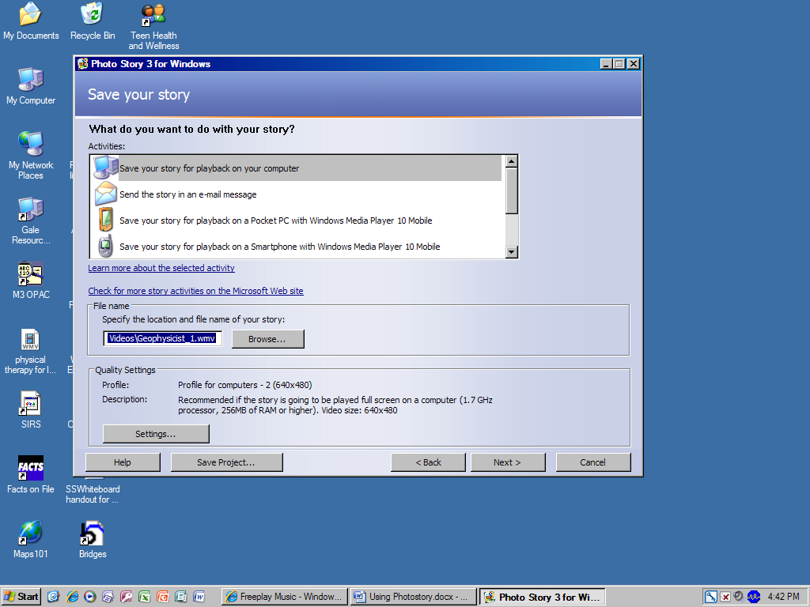

If you have content to ADD or plan to EDIT, save project… each day (overwrite previous file)

