Accessing itsLearning from Home PC or Mobile Device
From Home PC
- Go to https://harford.itslearning.com/Index.aspx
- The screen below should now be visible.
Click Here
- Make sure to click on “Log in with Harford Account”.
- Now the screen should look like this.
- Type your username and password as follows:
Username = firstnamelastname@student.hcps.org
Password = your current password for logging into the computers at school
- You should now have access to itsLearning.
From Mobile Device
- Go to https://harford.itslearning.com/Index.aspx
- The screen in Fig. 1 below should now be visible.
Fig. 1
Fig. 2
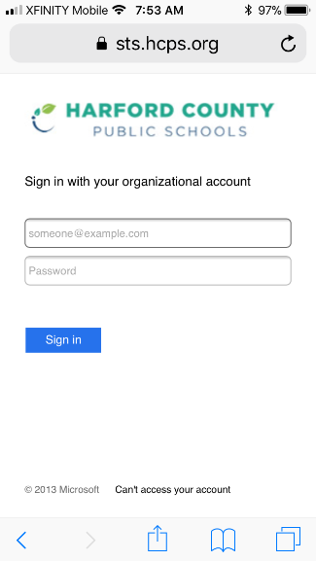

Click Here

- Make sure to click on “Log in with Harford Account”.
NOTE: the page may show a login section in the middle of the screen. Even if this happens, be sure to click “Log in with Harford Account” which will be below the username and password boxes.
- Now the screen should look like Fig. 2 above.
- Type your username and password as follows:
Username = firstnamelastname@student.hcps.org
Password = your current password for logging into the computers at school
- You should now have access to itsLearning.

